Project Online to Altus Migration
UAT and Priority Support Process

March 2026
Contents
Testing & Issue Resolution Support Process 3
Altus Non-Production Environment 4
Altus Development Environment 4
Altus Test Environment 4
Altus Production Environment 4
Considerations 4
Test Stages 5
Issue Priority Definitions 5
Issue Status Definitions 6
How to raise an issue 7
Altus one-week priority support Process 8

Testing & Issue Resolution Support Process
This section outlines the testing and issue resolution support process that will be followed during the Project Online to Altus migration implementation. The purpose of this process is to provide a structured approach for validating the solution, managing issues identified during testing, and ensuring that the Altus environment is ready for production use.
The process defines how testing will be conducted across the Development, Test, and Production environments within the client’s Microsoft 365 tenant, as well as the roles and expectations for both the implementation team and the client during the testing period. It also establishes a consistent method for logging, tracking, prioritising, and resolving issues through the shared project collaboration site.
By following this approach, the project team can ensure that configuration changes, migrated data, integrations, and user access are appropriately validated prior to go-live. This helps reduce risk, improve transparency in issue management, and support a smooth transition to the live Altus production environment, including the initial post–go-live priority support period.
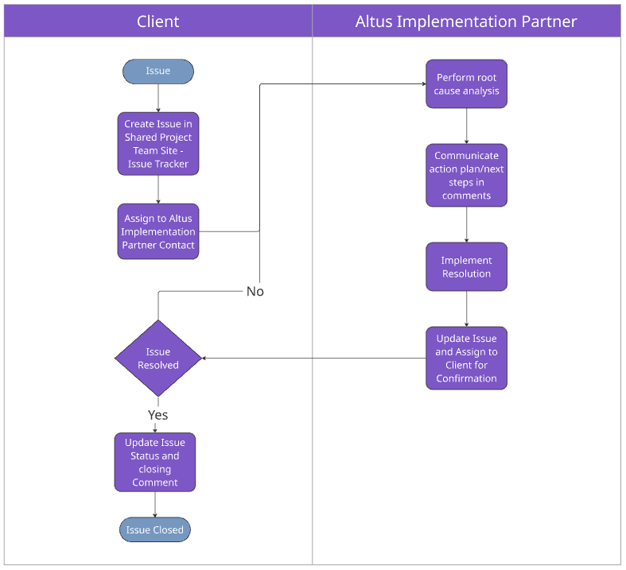

Altus Non-Production Environment
The Altus implementation will be delivered across three primary environments within the client’s Microsoft 365 tenant: Development, Test, and Production. Each environment serves a specific purpose in the deployment lifecycle, helping to ensure that configuration, migration activities, and validation are carried out in a controlled and structured manner before the solution is made available to end users.
Using this staged approach allows the implementation team to safely configure and validate the Altus solution, migrate and verify project data, and enable client stakeholders to conduct testing before the system is released for operational use. This environment structure reduces risk, supports quality assurance, and ensures that the Production environment remains stable and ready for business use at go-live.

Altus Development Environment
The Development environment is used by the implementation team to deploy and configure the Altus solution within the client’s Microsoft 365 tenant. This environment is used for solution configuration, migration preparation, testing of configuration changes, and validation of integrations or customisations before they are promoted to later environments. It provides a safe working space where changes can be made without impacting user testing or live operations.

Altus Test Environment
The Test environment is used to validate that the Altus solution configuration and migrated data operate as expected before being released to production. This environment is typically used for system testing and User Acceptance Testing (UAT) by nominated client stakeholders. It provides a controlled environment that mirrors production as closely as possible, allowing users to verify functionality, confirm business processes, and identify any issues prior to go-live

Altus Production Environment
The Production environment is the live operational environment where the Altus solution is used by the organisation’s end users to manage projects, portfolios, and related processes. Following successful testing and approval, the configured solution and migrated data are deployed to this environment for ongoing business use. Changes to this environment are controlled through agreed governance processes to ensure system stability and data integrity.

Considerations
The following considerations should be made during the testing phases of this project:
Consideration | Description
Availability of key testers | The client should nominate appropriate business representatives (for example PMO administrators, project managers, and team members) to participate in testing. These individuals should be familiar with current processes and able to validate whether the system behaves as expected following the migration.
Data validation | Users should review a representative sample of migrated projects to confirm that key information has migrated correctly. This may include project schedules, project metadata fields, financial information, risks and issues, and supporting documentation where applicable.
Security and access validation | Testers should confirm that the correct users and groups have access to the appropriate areas of the system. This includes validating permissions for PMO administrators, project managers, and team members to ensure security roles and Dataverse access are functioning as per the out of the box Altus security permissions assigned.
Testing of integrations and add-ins | Where applicable, users should confirm that supporting tools such as the Altus for Project Desktop add-in, Altus for Teams and Power BI reporting operate correctly with the migrated data and configured solution.
Change freeze during testing | To maintain a stable testing environment, a temporary change freeze should be applied during the UAT period. This ensures testers are validating a consistent configuration and avoids introducing new changes that could affect testing outcomes.
Test cases documentation | Creation of UAT test cases to cover functionality and business specific requirements is not in scope for this project. UAT is the responsibility of the Client to execute including developing end to end testcases and datasets for all required test types (functional and non-functional).
Client Specific Documentation | Any additional test or client specific documentation above what is already specified in the statement of work/description of services is out of scope for this engagement.

Test Stages
Activity | Description
Ad-hoc Unit Testing | Targeted testing performed by the implementation team throughout the configuration and migration process to validate that individual solution components are functioning as expected. This includes verifying configuration settings, data integrity following migration activities, integrations, security roles, and key functional areas within the Altus solution before the system is made available for broader user testing.
Final System UAT | A 3-day cycle of User Acceptance Testing (UAT) to be conducted by the Client immediately following the completion of the data migration. During this period, nominated client representatives will validate that the migrated data, configured functionality, and key business processes operate as expected within the Altus solution. It is mutually agreed that a change freeze will be in effect during this period to limit scope creep and ensure testing is conducted against a stable system baseline.
Priority Support Period (Post Go-Live) | A one-week priority support period commencing on the agreed production go-live date. During this time, the implementation team will prioritise the investigation and resolution of issues reasonably attributed to the data migration or solution deployment. All items logged within this period will be actioned and responded to as efficiently as practically possible, even if the resolution of those items extends beyond the one-week period. Issues raised after this support window may require additional effort and associated fees to investigate and resolve.

Issue Priority Definitions
Below is a description of the Issue Priority options and their definitions:
Priority | Description
Critical | A critical issue is one that prevents the system from operating, or blocks core functionality required for go-live or ongoing business operations. This type of issue typically affects many users or prevents key Altus capabilities from functioning, such as the inability to access the system, failure of the data migration, or major data integrity problems. Critical issues require immediate investigation and resolution and may delay testing completion or go-live until resolved.
High | A high priority issue significantly impacts important functionality but does not completely prevent the system from operating. These issues may affect specific business processes, user roles, or areas of the solution, such as incorrect behaviour in key configuration areas, issues with project schedule interaction, or problems with reporting or integrations. High priority issues should be addressed as soon as possible during the implementation or testing cycle to minimise disruption.
Normal | A normal priority issue represents a functional problem that has a moderate impact on usability but does not prevent users from continuing their work. These issues may involve non-critical configuration behaviour, minor data inconsistencies, or functionality that operates differently than expected but still allows the overall process to continue. These items are typically addressed as part of the standard issue resolution process.
Low | A low priority issue has minimal impact on system operation or business processes. These issues may include cosmetic display problems, minor usability concerns, documentation clarifications, or enhancement suggestions. Low priority items are typically recorded for later resolution or consideration in future configuration updates rather than requiring immediate action during the implementation period.

Issue Status Definitions
Below is a description of the Issue Status options and their definitions:
Priority | Description
New | The issue has been reviewed and is currently being investigated or actively worked on by the implementation team. Analysis, troubleshooting, or corrective actions are underway to determine the root cause and implement a resolution.
In Progress | The issue has been reviewed and is currently being investigated or actively worked on by the implementation team. Analysis, troubleshooting, or corrective actions are underway to determine the root cause and implement a resolution
Completed | The issue has been resolved, and the required corrective action has been implemented. The fix has been validated by the implementation team and, where applicable, confirmed by the client that the issue no longer occurs.
Blocked | Work on the issue cannot proceed due to a dependency or external factor preventing progress. This may include awaiting information, access, configuration changes, or decisions from the client or another party before investigation or resolution can continue.
Duplicate | The issue has been identified as a duplicate of another issue already logged in the issue register. The duplicate record is closed and linked to the original issue where the investigation and resolution will be managed.
By Design | Following investigation, the behaviour reported has been confirmed as the intended or expected behaviour of the system. No corrective action is required as the functionality is operating according to the design of the Altus solution or the underlying Microsoft platform.
Won’t Fix | The issue has been reviewed and acknowledged, but it has been agreed that no corrective action will be taken. This may occur where the issue has minimal impact, the effort required to resolve it outweighs the benefit, or it falls outside the agreed scope of the implementation.

How to raise an issue
- Navigate and login to the Project Online to Altus migration Team Site
- Under the General channel, select the Issue Tracker Tab and click the + Add new item button.
  - 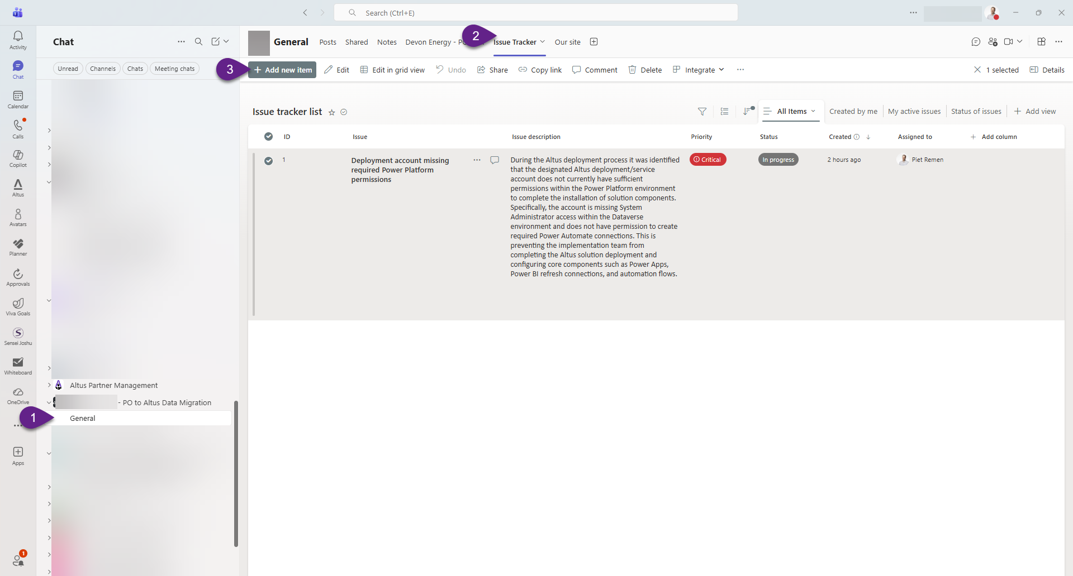
- Enter the name/title of the issue
- Click the pencil icon to edit the description area. Enter a detailed description, along with screen shots and steps on how to reproduce the issue to avoid vague time inefficiencies between the support technician and resolution time.
- Set the priority based on the following matrix: Issue Priority Definitions
- Set the Status appropriately based on the following matrix: Issue Status Definitions
- Assign the issue to the Altus Implementation Project Manager (IPM) or directly to another individual if known and available to select from.
- Note, the resolution area will be completed by the responding support technician, along with additional comments on status that will be attached to the issue item.
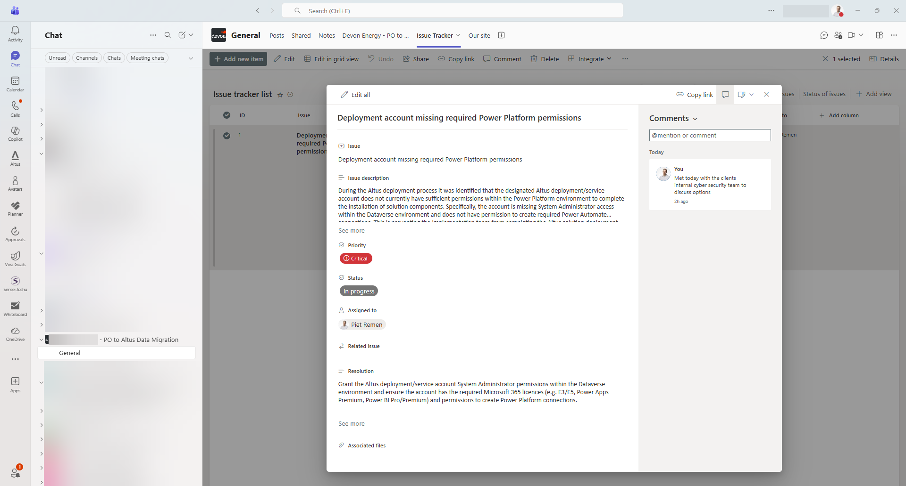

Altus one-week priority support Process
The purpose of the one-week priority support period is to provide focused post-go-live assistance during the initial transition to the new production environment. This period allows the implementation vendor to rapidly respond to any issues that may emerge once users begin operating in the live Altus production system, particularly those related to the completed data migration activities. It provides the project team with confidence that any migration-related concerns can be quickly assessed and addressed while the solution is being actively adopted by users.
By concentrating support during this early stage of production use, the vendor can efficiently validate that the migrated data is functioning as expected within the client’s environment and resolve any confirmed migration issues with minimal disruption to ongoing operations. This approach helps ensure a smooth stabilisation period immediately following go-live before transitioning the solution into standard ongoing support arrangements.
It is important to note that the one-week priority support period will commence on the agreed initial production go-live date. During this period, any issues logged that can reasonably be attributed to in-scope data migration activities will be reviewed, actioned and responded to by the implementation vendor as efficiently as practicable. Where investigation or resolution of these issues extends beyond the one-week period, the vendor will continue working towards resolution.
Issues raised after the one-week priority support period has concluded will fall outside the included support scope and may require additional fees for investigation and resolution.

